In this lesson we will talk about pressable in React native what are they It is a similar component to button inside which we can give onPress event but we can also give it in button, Touchable opacity and Touchable Highlight and we have talked about them in previous lessons then why are we studying it and why react native made it its benefit is that on this there is not only one event of press event but there are four events in onPress there we have just one normal onPress was there but here we have a normal onPress event and there is pressin and there is onPressout and there is onlongpress there Now you might have question about it they have given so many events on this button but what we will do about them we can press only one time what is its benefit see such things are used in which we want multiple event on a button whenever we are making an animated application or you are making a game then there are used the most

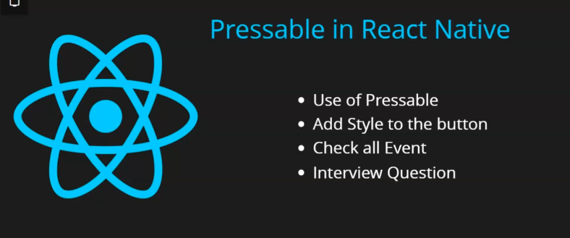Teacher is telling us an example suppose you are playing a game inside which you press a normal button now when you press first tiem then gun gets up in alien invasion game and when you keep pressing it then bullets start to get fired and as you leave the press then that gun get down or the bullets that are being fired get stopped such events you must have definitely seen it on animation such things are made so whenever you want to make such things then we can use Pressable even f you want ot use single onPress event then Teacher recommend then you can button and other things

When you want to use multi events on a single button or a component (who knows) then you can use Pressable It is not some old feature it is recently updated you can check it in documentation

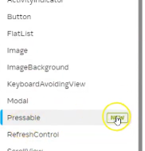

New batch is attached to it (in Teachers time)

So if you are working on an old react native version then this feature might not work but it will definitely work in latest version so Teacher has told its use Now we will import a Pressable and will add style on it so it should look like a button and then we will fire some events and he will do a normal console we could not make game in one lesson and at last we will discuss some interview question so we come to code

For now our code look like below

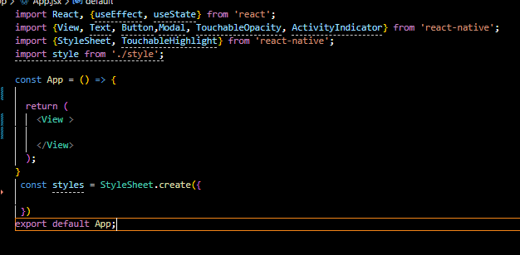

So we first import Pressable and then we use it inside the view and it is a container tag so it will be closed after adding initially you will not see anything I think you need to create its style like you did it Touchable opacity we take text component inside this Pressable and write pressable Now our code look like below

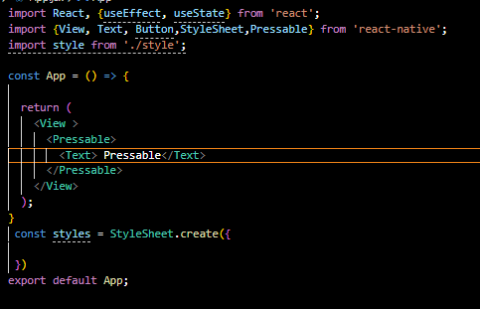

And our output look like below

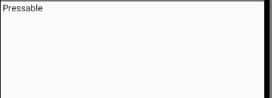

It is looking a like a normal text and not looking like a button so we need to apply some styles here

So we create a new style sheet and store it inside the styles constant we add main property there that is added to the top view so we add a flex here and then also justifyContent to make its content center. Now we add a property pressableBtn to the styles which will be added to the text component of pressable Now we add background blue and color white a, padding to 10 pixel , margin to 10 pixel and border radius to 10 pixel and make the fontSize to 20 and then we added textAlign to the center. Now it is like a button

Now our code look like below

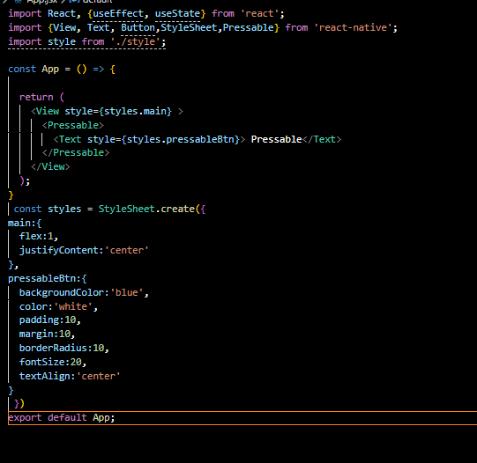

Now our output look like below

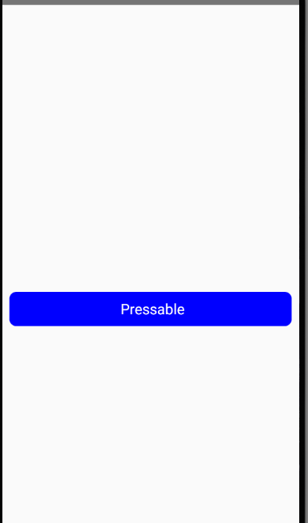

It is not looking like exact button we need to add shadow on it so we add black color for the shadow by shadowColor and we set the elevation so that we could show the shadow we set the elevation to 5

Now our style look like below

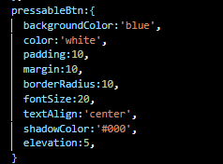

Now our output look like below

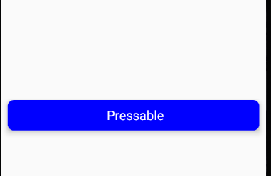

Now as Teacher said that he will tell the events one by one. So first teacher show normal event that is onPress and we add console warn in our onPress code and print normal on press

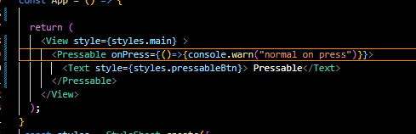

Now our design code look like above

And now our output look like below

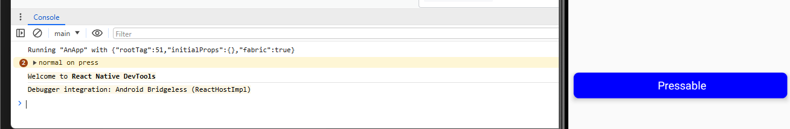

So we click on the pressable button and then our console will be printed as shown above

Now if we press down the button and hold it then we will not see any console because the press we did was a long press and it can be handled by the prop onlongPress in our Pressable component Now you will see that how differently they will be called so inside it we pass the callback console log the message ling press Now if we long press the Pressable then you will see the message as shown below

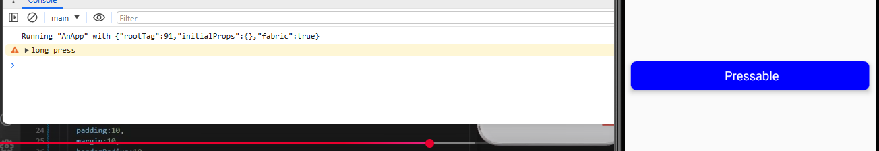

Now our code will look like below

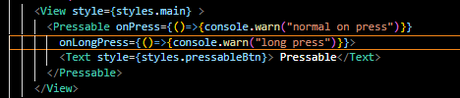

Now the two events are remaining and what are those which are onPressin Now whe you press in the button and it gets down then this event will be called so we use prop onPressIn in Pressable and in its callback we print the message “press in” and similarly we use prop onpressOut and print the message press out which will be called when the we leave the press. So we comment the prop of ompress and onlongpress and our code now look like below

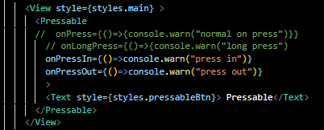

Now our output look like below

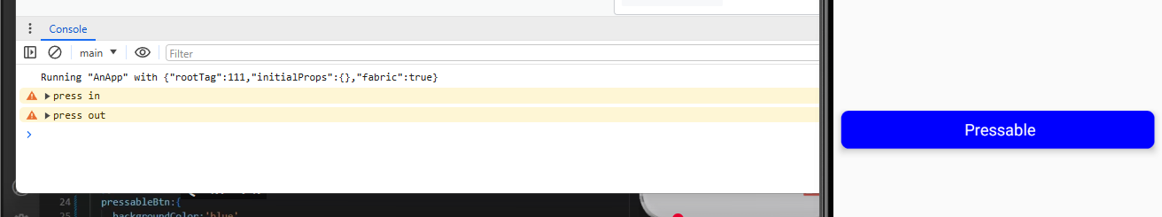

Now we press in and then press out then I see the two messages for press in and then press out

There is also hover events but it is out of scope and it does not even work in mobiles

So by this way we can use these four events if we try four of the events then you get to see three events work long press works separately (maybe it is because long press runs when we do long press on the Pressable component ) and also onPress run separately. It means if I just click a button then

Pressin , pressout and onpress will run and if we do long press then pressin , longpress and pressout will run.

You may add code for all the four events but only three of four event will run. And there use will be separate.

9:09

If you do long press then press in and then long press and then press out . In interview question you could be asked such as for long press event to be invoked how much time delay happens means how long you must press the button that this event happens this could be asked its answer will be half second means 500 millisecond if you see in documentation (in Teacher time)

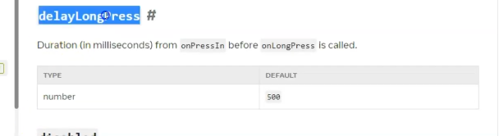

You can see in delay long press now you can see it is written that its default value is 500 milliseconds and then if you wat to modify the change then you can do change it with delayonPress How you can do it the teacher will told it for us it is a nanotask do it yourself and tell what to write that long press time changes. Teacher will make a separate course for Typescript but I this course we will see stack navigation drawn navigation(who knows) we will study whole navigation or api in upcoming lessons. See you in the next lesson.